**Exploring the effects of facemasks and lockdowns on Covid-19 transmission.**

**Abstract**

This study investigates the effects of facemask usage and lockdown interventions on the transmission dynamics of COVID-19 using a Susceptible-Infected-Recovered-Susceptible (SIRS) model. Building on existing research, this study incorporates a loss of immunity parameter to reflect observed reinfection patterns. The results reveal that a fully-masked population, in conjunction with periodic lockdowns, significantly flattens and delays the peak of infections, preventing subsequent waves and potentially ending the pandemic. The results show that transmission rates can be reduced to a point where the pandemic begins to decline when facemask coverage and effectiveness is high. Statistical significance of facemask and lockdown measures on reducing the rate of infections has been shown, although these need to be combined to fully eradicate the pandemic. The novel introduction of recovered individuals becoming susceptible, highlights the emergence of cyclical reinfection waves when mask coverage is suboptimal, emphasizing the importance of sustained interventions. While the model is validated against existing literature, there are knowledge uncertainties and assumptions in the SIRS model which may limit its applicability to specific contexts. Nevertheless, the findings provide critical insights for informing evidence-based policies and preparedness for future pandemics.

1. **Introduction**

Covid-19 is a virus species *severe acute respiratory syndrome related coronavirus* (named SARS-CoV-2) and was first identified in December 2019 in Wuhan, China (Stutt et al, 2020; Rahman et al, 2021). Within 5 months this virus had infected over two million people across 185 countries, leading to the outbreak being declared as a pandemic by the World Health Organisation on March 11th 2020 (Rahman et al, 2021). While initial cases of Covid-19 were linked to an animal market in Wuhan, the rapid global transmission was predominantly driven through human-human interaction (Rahman et al, 2021). Transmission of the virus occurs via airborne particles of SARS-CoV-2, expelled through coughing, sneezing and talking, which are subsequently inhaled by susceptible individuals (Van Doremalen et al., 2020; Stutt et al., 2020). The virus spreads more efficiently when susceptible populations are within close proximity and prolonged exposure to infected individuals (McBryde, 2020; Rahman et al., 2021).

During the pandemic, the main mitigation measures were physical social distancing, population lockdowns, and the use of facemasks (Stutt et al, 2021). The benefits of lockdowns and facemasks was met with global public scepticism, which lead to inconsistent implementation and enforcement of these measures (Taylor and Asmundson, 2021). Therefore, it is purposeful to understand the potential benefits of these interventions, as this could guide future evidence-based governmental policies for similar events, with the potential to save lives through relatively cost-effective measures (Stutt et al., 2020).

A range of mathematical models have been developed to evaluate the effect of lockdown and facemask implementation on Covid-19 transmission (Rawson et al, 2020; Sun and Li, 2020; Thompson, 2020; Zhao and Chen, 2020; Booton et al, 2021; Rahman et al, 2021; Stutt et al, 2020). Many of these models are complex, making their results difficult to interpret (Rahman et al, 2021). Despite this, Stutt et al (2020) explores these measures using an accessible Susceptible-Infected-Recovered (SIR) model. Building on this research, this paper adopts a similar experimental design, but uses a Susceptible-Infected-Recovered-Susceptible (SIRS) model to account for the observed gradual loss of Covid-19 immunity (Townsend et al, 2021). This study aims to provide further insights into the effectiveness of lockdown and facemask implementation on Covid-19 transmission.

1. **Methods**
   1. Model 1: Mask Efficiency against Percentage Population

Before incorporating facemask utilisation into the SIRS model, changes in the effective reproduction number (Re) as a result of facemask population coverage and mask effectiveness is explored. Re refers to the average number of secondary infections caused by an infected individual in a non-fully susceptible population (Stutt et al, 2020). Re values and their representations are shown (Table 1).

Table : Highlights the possible effective reproduction number (Re) values and what these values represent in the context of infection transmission.

|  |  |
| --- | --- |
| **Re Value** | **Representation** |
| Re>1 | Each infected individual infects more than one other person on average. Infection is likely to spread. |
| Re=1 | Each infected individual infects one person on average. Infection level remains stable. |
| Re<1 | Each infected individual infects fewer than one person on average. Infection will gradually decline and end. |

The code which explores facemask coverage against effectiveness is shown (Fig1).

This loop iterates over different values of R0 for different combinations of facemask coverage (***‘mask_coverage_range’***) and effectiveness (***‘mask_effectiveness_range’***) values. This loop adjusts the R0 based on these variables to produce an Re.

Fig1: Function used to calculate the effective reproduction number (Re) for different facemask coverage and effectiveness values.

R0 represents the average number of new infections caused by an infected individual in a fully susceptible population (Stutt et al, 2020). The R0 values are prescribed as 2.2 and 4.0, to show the range of possible values, as the true value is uncertain (Stutt et al, 2020). Both mask ranges are prescribed a range of 0-1 in steps of 0.1, which represents 0%-100% (with 10% intervals) population coverage and effectiveness.

* 1. Model 2: SIRS

The SIRS model is developed and utilised for modelling the transmission of Covid-19 across 540 days, with lockdowns and mask-wearing protocols being followed. The population is modelled proportionally, with the initial conditions set at 0.99, 0.01 and 0.0 for the Susceptible, Infected and Recovered respectively.

* + 1. Differential Equations

The model uses three differential equations to simulate the change in the proportion of Susceptible, Infected and Recovered people in a given population. These equations are shown (Fig2).

Fig2: SIRS differential equations used in the model.

The terms in these equations are described as followed:

* ***‘dS_dt’***, ***‘dI_dt’***, ***‘dR_dt’*** = rates of change of the Susceptible, Infected and Recovered population respectively.
* ***‘S’, ‘I’, ‘R’*** = proportion of the population that is Susceptible, Infected and Recovered respectively.
* ***‘beta’*** = transmission rate.
* ***‘delta’*** = rate of immunity loss.
* ***‘gamma’*** = recovery rate.
  + 1. Model Parameters

The model requires prescribed parameters, which are shown in Fig3 and described in Table 2.

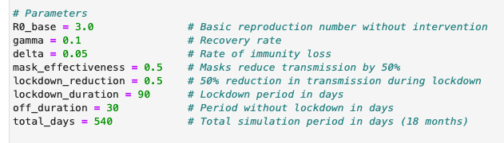

Fig3: Parameters prescribed to the SIRS model. The parameters that are not highlighted are given in all modelling scenarios. The variables highlighted in red are removed in the scenarios where lockdowns are not considered.

Table 2: Outlines the various parameters used in the SIRS model. Basic descriptions of each parameter is provided, along with their associated value used in the model. The reasoning and/or source for the chosen values is also given.

|  |  |  |  |
| --- | --- | --- | --- |
| **Parameter** | **Description** | **Value** | **Source/Reasoning** |
| R0_base | Basic reproduction rate | 3.0 | Stutt et al (2020) |
| gamma | Recovery rate | 0.1 | Assumed - limited data |
| delta | Rate of immunity loss | 0.05 | Assumed - limited data |
| mask_effectiveness | Proportion of transmission reduction due to facemask effectiveness | 0.5 | Stutt et al (2020) |
| lockdown_reduction | Proportion of transmission reduction due to lockdown | 0.5 | Stutt et al (2020) |
| lockdown_duration | Lockdown duration (days) | 90 | Stutt et al (2020) |
| off_duration | Duration without lockdown (days) | 30 | Stutt et al (2020) |
| total_days | Total simulation duration (days) | 540 | Stutt et al (2020) |

* + 1. Lockdown Function

The function used to model lockdowns is shown (Fig4).

Fig4: Defined function used to model lockdowns effectively in the model.

In line with Stutt et al (2020), the first lockdown starts on the 45th day for any given scenario (***‘first_lockdown_start’****=45*), and the lockdown durations and cycles remain constant (Table 2).

For each day, the function calculates the ***‘day_adjusted’***  by subtracting the initial lockdown day. If this value is negative, and therefore falls before day 45, a lockdown is not triggered. The function then calculates the cycle duration of the lockdowns and uses modular arithmetic to identify where the day lies within the cycle. If the day falls within the lockdown duration, the function returns a True value which indicates that the lockdown is active. If the day falls outside of the lockdown period, the function returns a False value and the infection rate remains at its base level.

* + 1. Modelling facemasks and lockdowns

To model the effect of facemask and lockdown implementation on the virus transmission, the base infection rate (***‘beta_base’***) is adjusted accordingly. ***‘beta_base’*** represents the infection rate without any interventions, and is calculated using the equation in Fig5, and the values in Table 2.



Fig5: Equation used to calculate the base transmission rate without any interventions.

This base value is then dynamically adjusted via the following equation (Fig6).

Fig6: Equations used to calculate the dynamic transmission rate, with the effects of facemasks and lockdowns considered.

The first stage of the code adjusts the beta value based on the populations facemask coverage (***‘mask_coverage’***) and the masks’ effectiveness (***‘mask_effectiveness’***). The mask effectiveness is kept constant (Table 2), with coverage values of 0, 0.25, 0.5 and 1.0 prescribed to represent a masked population of 0%, 25%, 50% and 100% respectively.

The second stage of the code determines whether the day is in a lockdown period using the function in Fig4. If the day lies within a lockdown period, the facemask adjusted beta value is halved, in line with the ***‘lockdown_reduction’*** value (Table 2). Where a lockdown scenario is not considered, this section is ignored. The resultant dynamic beta value (***‘beta’***) is then passed through the differential equations (Fig2).

1. **Results**
   1. Mask Efficiency against Percentage Population

As a greater proportion of the population wear masks of greater effectiveness, the reductions of Re are greater for all R0 conditions (Fig7(a)(b)). The Re is <1 when a large proportion of the population wear effective facemasks (Fig7(a)(b)). This Re boundary is more difficult to reach if the R0 is larger, with the requirement of a fully-masked population to wear a facemask of ~70% effectiveness when R0=4.0, as opposed to ~50% effectiveness when R0=2.2 (Fig7(a)(b)).

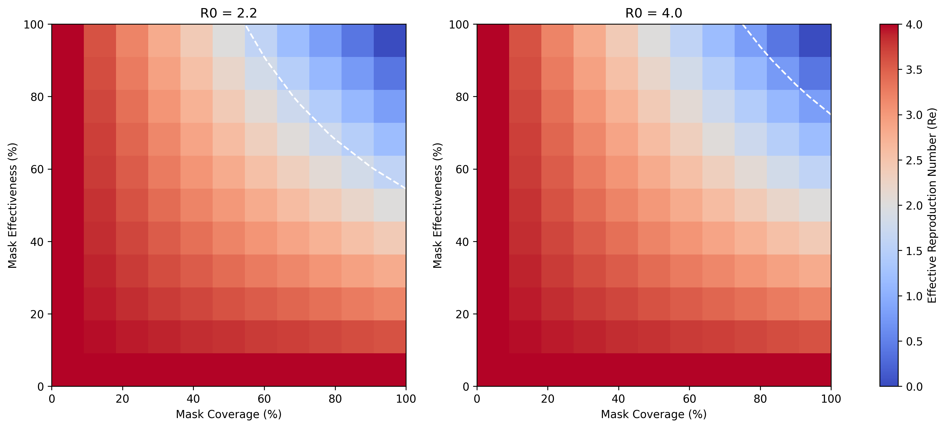

(a)

(b)

Fig7: Heatmaps showing the calculated effective reproduction number (Re ​) for various combinations of mask effectiveness (%) and mask coverage (%) for initial R0 values of (a) R0=2.2 and (b) R0=4.0. The white dashed line indicates Re=1.

* 1. SIRS Model

When combined with lockdown measures, the trends in the proportion of the infected population are similar for 0%, 25% and 50% masked populations (Fig8). For these scenarios, the infected population increases exponentially, until it peaks at ~day 30 before decreasing exponentially until the end of the first lockdown. Post-lockdown, the infected population increases exponentially, but is unable to reach the same peak magnitude, due to the 30-day intervals between lockdowns. This trend is evidenced for the remaining lockdown scenarios, with infection peaks of similar magnitude (Fig8). Although these scenarios display similar cyclical trends, the peak levels of infection decrease by ~15% for each 25% increase in coverage (Fig8). A fully-masked population throughout the pandemic shows considerably less fluctuations between lockdown periods, and does not display these trends (Fig8). Instead, there is no infected population post the third lockdown; suggesting an ending of the pandemic (Fig8).

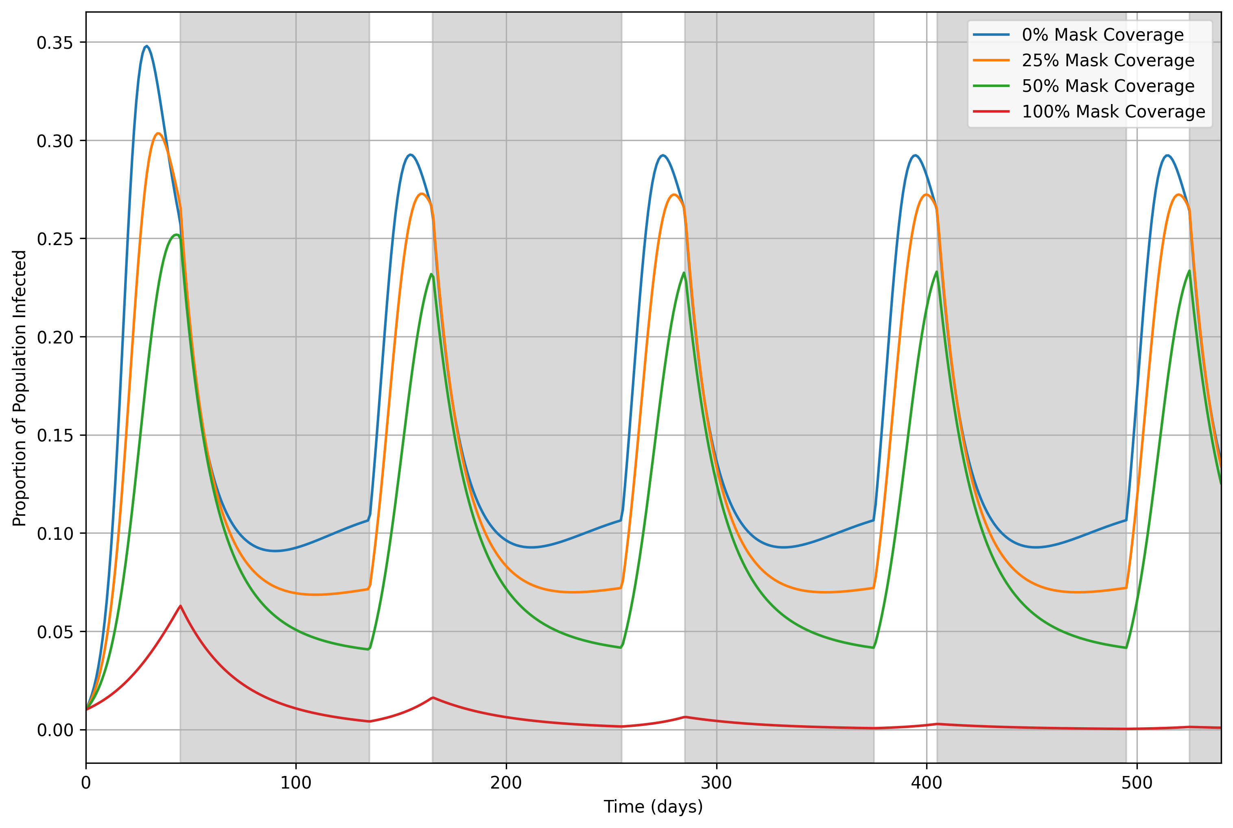

Fig8: Timeseries showing the proportion of the population infected over 540 days for mask coverage levels of 0% (blue line), 25% (orange line), 50% (green line), and 100% (red line). 90-day lockdown periods, starting at day 45, are highlighted with grey shading, with 30-day gaps between consecutive lockdowns. Facemask interventions start from day 0 and continue throughout the simulation period.

Even when a fully-masked population is implemented at later stages, there appears to be no infected individuals by the 540th day, when lockdowns are implemented (Fig9(a-d)). When facemasks are implemented before a lockdown, the rate of infection declines significantly (Fig9(a)). It is difficult to ascertain the extent to which this decline can be attributed solely to the introduction of facemasks, as a similar pattern has been evidenced when facemasks were applied at the beginning of the simulation (Fig8). When a masked population is implemented at a later date, the second wave of infections is greater post-lockdown, by ~60% per 30-day mask implementation delay (Fig9(a-d)). For all fully-masked scenarios that begin after day 0, the infected population peaks at ~0.35 around day 30, and then dramatically decreases; which is likely due to a large reduction in the susceptible population and thus a reduction in Re at this point (Fig9(a-d)).

Fig9: Timeseries showing the proportion of the population infected over 540 days for a mask coverage level of 100% (red line). Facemask interventions begin on day (a) 30, (b) 60, (c) 90, and (d) 120, continuing throughout the simulation. The start of the facemask intervention is indicated by the dashed blue line. 90-day lockdown periods, starting on day 45, are highlighted with grey shading, with 30-day gaps between consecutive lockdowns.

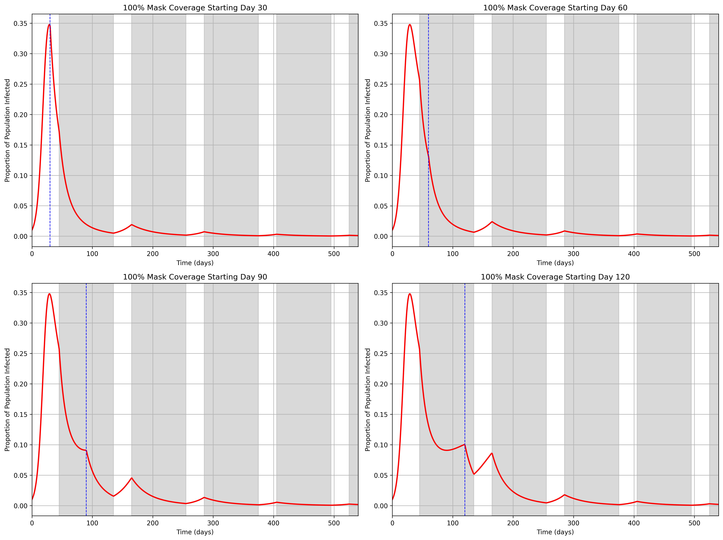

(a)

(b)

(c)

(d)

When lockdowns are removed completely, and facemasks are applied from the beginning of the pandemic, the infection peak still remains at ~day 30 for all scenarios (apart from a fully-masked population), but the magnitude decreases in line with increased mask wearing (Fig10). For a fully-masked population, this peak occurs at ~day 90 but the magnitude is less drastic (~0.012). Once these infection peaks are reached, the infected population stabilises from ~day 100. The amount of people infected at these stabilisation phases increases in line with a decreasing masked population (Fig10). Two-sample independent t-tests were conducted to assess the statistical significance of facemasks on peak infection levels and lockdowns on infections throughout the simulation. These tests demonstrated statistically significant reductions in peak infections across all facemask scenarios, when compared to 0% mask usage. For example, peak infections were significantly lower when mask coverage was 50% compared to 25% (t-statistic=11.16, p-value<0.001) and for when 100% coverage was compared to 50% coverage (t-statistic=45.33, p-value<0.001). Furthermore, lockdown measures displayed a statistically significant reduction in infection throughout the simulation, when compared to non-lockdown scenarios (t-statistic=-18.55, p-value<0.001).

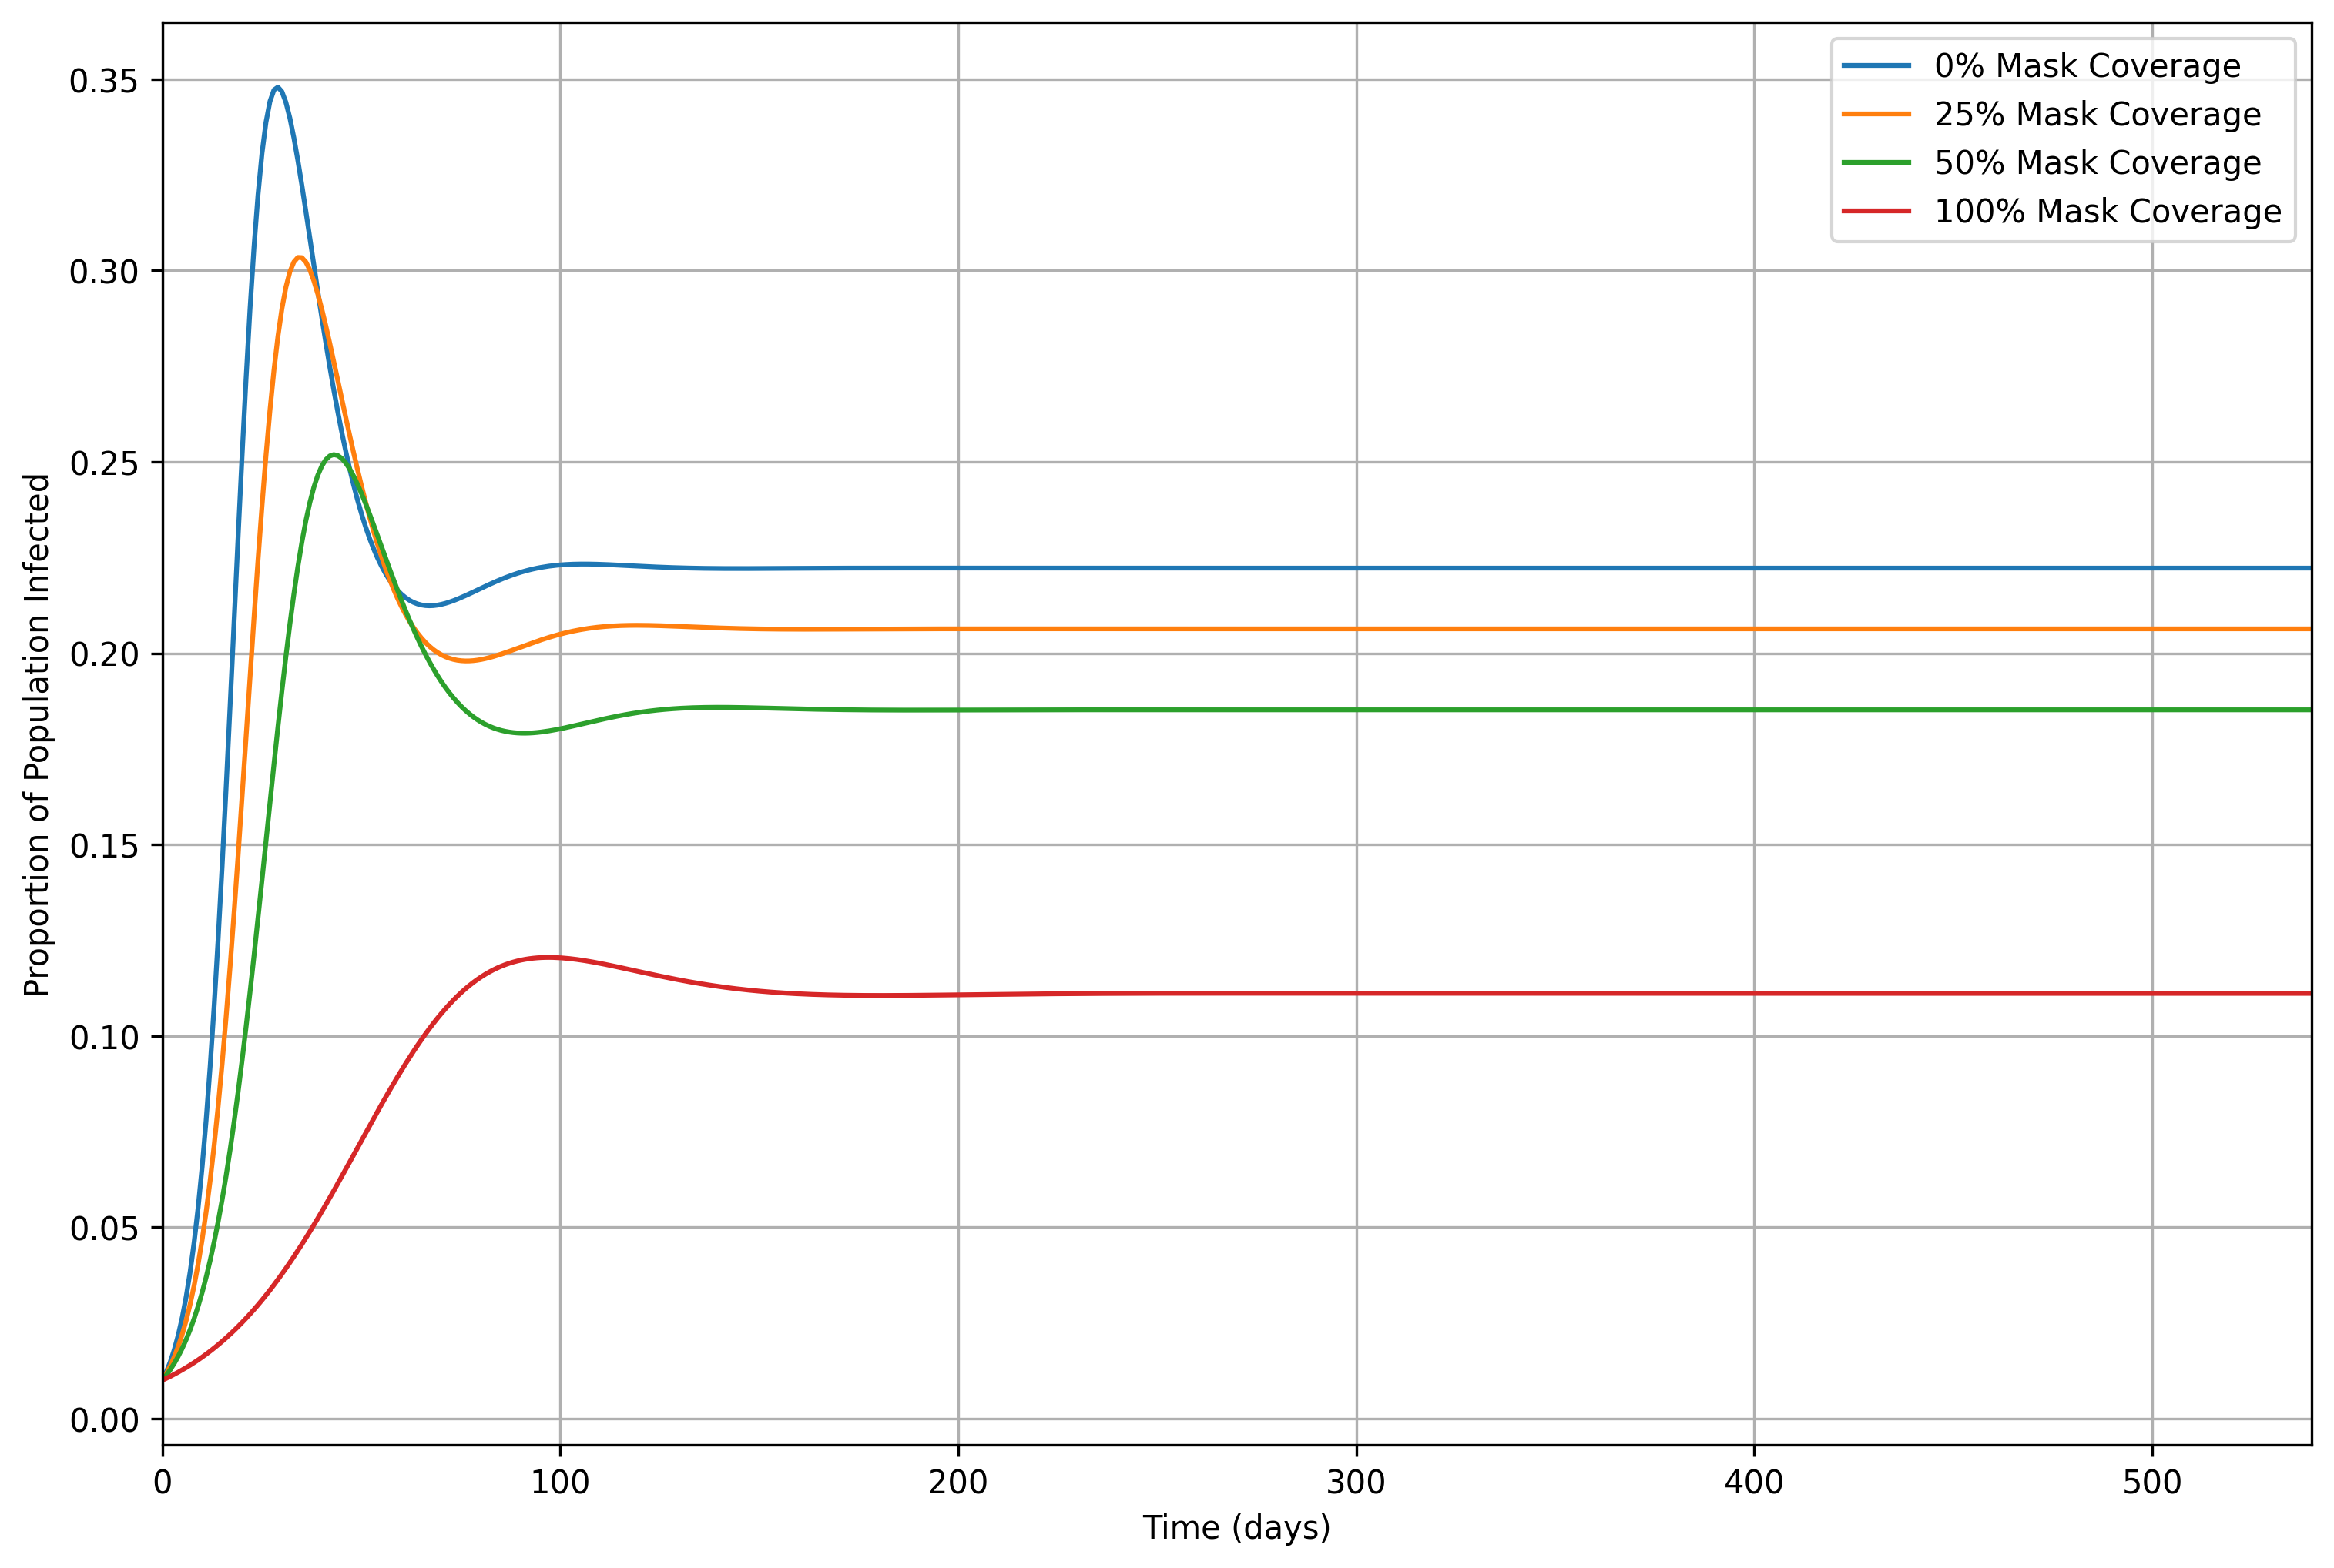

Fig10: Time series showing the proportion of the population infected over 540 days for mask coverage levels of 0% (blue line), 25% (orange line), 50% (green line), and 100% (red line). No lockdown interventions are included, and facemask interventions start on day 0 and continue throughout the simulation period.

1. **Discussion**

The findings from this research are largely comparable to similar studies, with high agreement that high mask effectiveness combined with a large proportion of the population wearing masks is enough to reduce transmission to levels that could end endemic conditions. (Stutt et al, 2020). Results displayed that only a fully-masked population, alongside lockdown implementation, is able to dramatically flatten and delay the peak of infections, whilst preventing subsequent reinfection waves. This is highly consistent with similar research (Stutt et al, 2020). Below a 100% population coverage, continuous waves of infection exist, which is a common characteristic of SIRS models due to the loss of immunity being accounted for (Bjørnstad et al, 2020). This is a key finding, however from current knowledge there is no literature that explores lockdowns and facemasks using this type of model and therefore the results given here cannot be directly compared. Similar studies do not account for the regeneration of the Susceptible population, and thus assume long-term immunity once an individual recovers (Stutt et al, 2020).

This research examined the effects of adopting facemasks, without the implementation of lockdowns, which showed a statistically significant flattening of the curve, with increasing facemask usage. At 100% adoption, this was effective enough to flatten the curve further but also delay the peak infection by ~60 days. This is consistent with similar research and emphasises the potential significance of public facemask use on reducing transmission pandemic (Eikenberry et al, 2020; Stutt et al, 2020). For these scenarios, the infected population stabilised at similar times, which is likely due the virus’ ability to spread being constrained by the balance between the susceptible population, recovery rate and the rate of immunity loss (Vargas-De-León, 2011).

Although both lockdowns and facemask interventions were shown to significantly reduce the rate and peak of infections statistically, it is unlikely that these measures in isolation would be enough to eradicate the pandemic. This is consistent with Stutt et al (2020), and instead a combination of these measures would be needed for successful eradication. Contextually, it is highly unlikely that a fully-masked population is logistically possible due to mask hesitancy (Taylor and Asmundson, 2021). Instead, this research has shown that similar transmission rate declines can be achieved with greater mask effectiveness and less population coverage. This is plausible, as cotton-fabric masks have been shown to have a droplet-blocking and filtration efficiency of 43%-100%, meaning that effective masks can be made easily available to the public at a reasonably low cost, without diminishing the availability of personal protective equipment for key workers (Stutt et al, 2020).

Before concluding this research, it is important to note the inherent uncertainties within the SIRS model. Firstly, due to knowledge uncertainties, a proportion of the parameter values have been assumed and may not be contextually representative (Table 1). In addition to parameter uncertainties, the SIRS model assumes a constant population size and homogenous mixing. Additional factors that are ignored in this research include: population heterogeneity, seasonality, regionality and exposure (Stutt et al, 2020; Wang et al, 2020; Rahman et al, 2021). The amalgamation of these knowledge gaps and uncertainties may limit the model applicability to model contextual problems. Although these limitations exist, the model results are comparable with those in existing literature which validates the SIRS model for exploring fundamental epidemiological dynamics.

To conclude, this research has reinforced the critical role of facemask and lockdown intervention in mitigating the transmission of Covid-19. By using a SIRS model, this study highlights the potential for consistent reinfection waves when mask coverage is below 100%, which is a novel contribution to this field of research. Although the effectiveness of facemasks and lockdowns in tandem has been validated for halting the Covid-19 pandemic, contextual issues means that achieving a fully-masked population is very unlikely. Despite this, there are plausible opportunities to reach similar transmission rate reductions through increased mask effectiveness. Inherent uncertainties exist within the SIRS model, but validation of its results supports the use of this model for exploring epidemiological problems. This places confidence that this SIRS model could be a critical tool for guiding governmental policies for similar future events.

**References**

* Bjørnstad, O.N., Shea, K., Krzywinski, M. and Altman, N., 2020. The SEIRS model for infectious disease dynamics. *Nature methods*, *17*(6), pp.557-559.
* Booton, R.D., MacGregor, L., Vass, L., Looker, K.J., Hyams, C., Bright, P.D., Harding, I., Lazarus, R., Hamilton, F., Lawson, D. and Danon, L., 2021. Estimating the COVID-19 epidemic trajectory and hospital capacity requirements in South West England: a mathematical modelling framework. *BMJ open*, *11*(1), p.e041536.
* Eikenberry, S.E., Mancuso, M., Iboi, E., Phan, T., Eikenberry, K., Kuang, Y., Kostelich, E. and Gumel, A.B., 2020. To mask or not to mask: Modeling the potential for face mask use by the general public to curtail the COVID-19 pandemic. *Infectious disease modelling*, *5*, pp.293-308.
* McBryde, E., 2020. The value of early transmission dynamic studies in emerging infectious diseases. *The Lancet Infectious Diseases*, *20*(5), pp.512-513.
* Rahman, A., Kuddus, M.A., Ip, R.H. and Bewong, M., 2021. A review of COVID-19 modelling strategies in three countries to develop a research framework for regional areas. *Viruses*, *13*(11), p.2185.
* Rawson, T., Brewer, T., Veltcheva, D., Huntingford, C. and Bonsall, M.B., 2020. How and when to end the COVID-19 lockdown: an optimization approach. *Frontiers in Public Health*, *8*, p.262.
* Sun, P. and Li, K., 2020. An SEIR model for assessment of current COVID-19 pandemic situation in the UK. *medRxiv*, pp.2020-04.
* Taylor, S. and Asmundson, G.J., 2021. Negative attitudes about facemasks during the COVID-19 pandemic: The dual importance of perceived ineffectiveness and psychological reactance. *Plos one*, *16*(2), p.e0246317.
* Thompson, R.N., 2020. Epidemiological models are important tools for guiding COVID-19 interventions. *BMC medicine*, *18*, pp.1-4.
* Townsend, J.P., Hassler, H.B., Wang, Z., Miura, S., Singh, J., Kumar, S., Ruddle, N.H., Galvani, A.P. and Dornburg, A., 2021. The durability of immunity against reinfection by SARS-CoV-2: a comparative evolutionary study. *The Lancet Microbe*, *2*(12), pp.e666-e675.
* Van Doremalen, N., Bushmaker, T., Morris, D.H., Holbrook, M.G., Gamble, A., Williamson, B.N., Tamin, A., Harcourt, J.L., Thornburg, N.J., Gerber, S.I. and Lloyd-Smith, J.O., 2020. Aerosol and surface stability of SARS-CoV-2 as compared with SARS-CoV-1. *New England journal of medicine*, *382*(16), pp.1564-1567.
* Vargas-De-León, C., 2011. On the global stability of SIS, SIR and SIRS epidemic models with standard incidence. *Chaos, Solitons & Fractals*, *44*(12), pp.1106-1110.
* Zhao, S. and Chen, H., 2020. Modeling the epidemic dynamics and control of COVID‐19 outbreak in China. *Quantitative biology*, *8*(1), pp.11-19.